**Linked List**

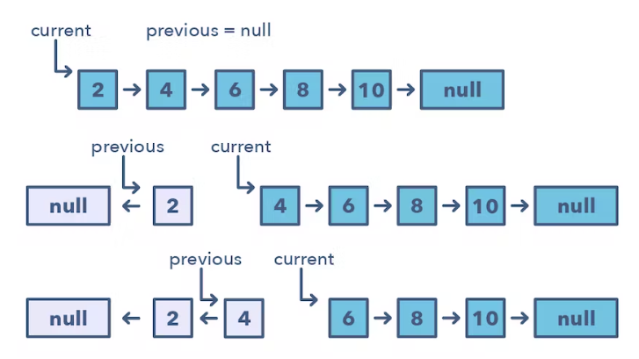

**Ways to Identify the pattern:**

* If you’re asked to reverse a linked list without using extra memory

**Common problems you use the sliding window pattern with:**

* Reverse a Sub-list (medium)
* Reverse every K-element Sub-list (medium)

**Broad Categories:**

* None.

**Strategies to Solve the Problem:**

* Make sure to always store the current node before moving on to next element

def reverse(head):

  previous, current, next = None, head, None

  while current is not None:

    next = current.next  # temporarily store the next node

    current.next = previous  # reverse the current node

    previous = current  # before we move to the next node, point previous to the current node

    current = next  # move on the next node

  return previous